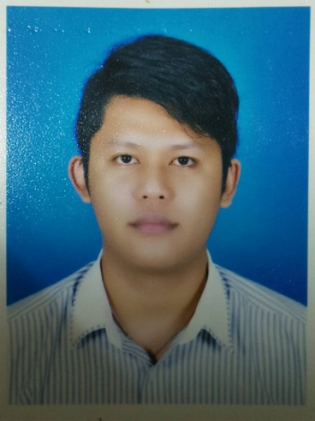

**Name : Rosehaidi Bin Kasim**

**Address : Lot6 Blok12 Lorong17 Taman**

**Rajawali Batu7 Jalan Airport**

**Sandakan**

**Contact Number : 014-9533915**

**Email : rosehaidikasim@gmail.com**

PERSONAL PARTICULAR

**I.C No** : 890120-12-6327 **Race**: Bajau

**Age** : 32 **Nationality :** Malaysia

**Date of Birth** : 20/01/1989 **Health**  : Excelent

**Religion** : Islam **Height**  : 182cm

**Place of Birth** : Sandakan **Weight** : 86kg

**Gender** : Male **Driving Licence**  : D

**Marital Status** : Married **Posses own vehicle** : Yes

EDUCATIONAL BACKGROUND

**Highest Education**

**Level > Diploma in Automotive Diesel Engineering**

**Major > Mechanical Engineering**

**Institution > Polytechnic Kuching Sarawak**

**Graduate > July 2013**

**CGPA > 2.88**

**Second Highest Education**

**Level > Certificate in Automotive Diesel Engineering**

**Major > Mechanical Engineering**

**Institution > Polytechnic Kuching Sarawak**

**Graduate > 31 December 2009**

**CGPA > 2.84**

**Third Highest Education**

**Level > Sijil Pelajaran Malaysia (SPM)**

**Major > Automotive Technology**

**School > S.M Teknik Sandakan**

**Achievement > 6 credits 3 pass**

**Year > 2006**

**Fourth Highest Education**

**Level > Penilaian Menengah Rendah (PMR)**

**School > S.M.K Merpati**

**Achievement > 2A 2B 4C**

**Year > 2004**

Skills

* **Fluent in writing English and Malay**
* **Speak fluent in English and Malay**
* **Certificate of Competence Multipoint Injection Engine Diagnose and Trouble Shooting Electric and Electronic Wiring**
* **Computer programme (windows XP , Microsoft Word , Microsoft Excel)**

Working Experience

* **Industrial Training at Edaran Otomobil Nasional BHD.**

**> (July-December ) 2008**

* **Bio Gas Shift Technician at Seguntor Bio Energy**

**> (April-June) 2011**

* **Assistant Manager at Restaurant Sri Gading**

**> (May-December) 2012-2016**

* **Technician at Clean Pro Express > 2017-2018**
* **Process operator/Lab Attendent/Boiler fireman at Ijm Edible Oil Sdn Bhd (Sugut Region) > 2018-2020**
* **Plant Operator at IJM Kernel Crushing Plant Sandakan. >2020-present**

Activities & Achievement

**Interest :** Camping , Travelling

**Hobby :** Soccer and Futsal

**Achievement :** Soccer Player at High School and Polytechic

:Clean List Semester ( Diploma)

:Clean List Semester (Certificate)

:Head of Department Awards (Certificate)

Others

**Career Ambition = To give my best service that target in my work weather it is any field or any job**

**Expected Salary = RM1700 ++ (Negotiable)**

Reference

The following persons have to provide my additional information regarding my qualification and character

**Name : En.Khairul Bin Domadi**

**Contact : 012-6621434**

**Designation : Lecturer**

**Work Place : Polytechnic Kuching Sarawak**