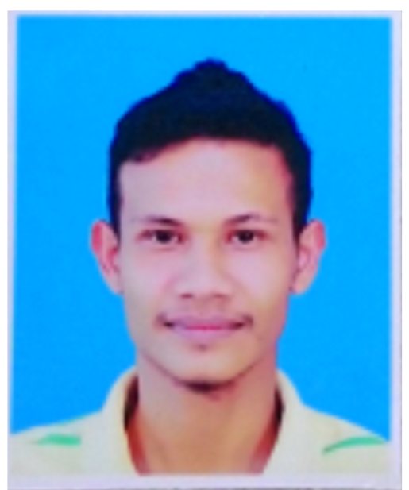

**MUHAMMAD KAMARULNIZAM BIN MUSA**

**921216-03-5525**

**OBJECTIVE**

1. To enhance my knowledge and of skills in the plantation.
2. To get new experience and challenge in new company.

**PERSONAL INFORMATION**

Name : Muhammad Kamarulnizam bin Musa

I/C No : 921216-03-5525

Age : 28 years

D.O.B : 16 December 1992

Marital status : Married

Nationality : Malaysia

Race : Malay

Religion : Islam

Sex : Male

Driving license : B, D

Tel no : 019-5103792

Address : KG. Bechah Kida To’uban 17050 Pasir Mas,Kelantan

Email : kamal.nizam1612@gmail.com

**EDUCATION HISTORY**

**Diploma Education**

Course : Diploma in Planting Industry Management

Institution : UITM Jengka Pahang

**High School Education**

School : Sekolah Menengah Kebangsaan To’uban,Pasir Mas,Kelantan

Education Period : January 2005 – December 2009

Certification : SPM 2009 - PASS

PMR 2007 - PASS

**Primary School Education**

School : Sekolah Kebangsaan To’uban, Pasir Mas, Kelantan.

Education Period : January 1999 – November 2004.

Certification : UPSR 2004 - PASS

**LANGUAGE SKILL**

Language : Malay, English

Writing : Malay, English

|  |  |  |
| --- | --- | --- |
| **Language** | **Speaking** | **Writing** |
| Malay | Excellent | Excellent |
| English | Good | Good |

**EXPERIENCES**

**SIGUR ROS PLANTATION SDN BHD**

**2014-2017**

**Position: Field conductor**

1. Have practical 3-month experience in supervisor at Sigur Ros plantation

2. Have 3 years’ experience in supervisor at Sigur Ros plantation

3. Have experience in GPS

4 Have experience in tapping, manuring, weeding and pest control.

5 Have experience to supervise in field worker in general management.

**FOCUS BONANZA PLANTATION SDN BHD**

**2018-PRESENT**

**Position: Assistant manager**

1. In-charge of maintenance rehabilitation work, manuring and harvesting.
2. In-charge of MSPO.
3. I am competent person in certified environmental professional in scheduled waste management (CePSWANS)
4. I have certificate of competency in FIRST AID at WORKPLACE.
5. I have certificate in understanding of MSPO MS 2530-3:2013 requirements, legal requirements, risk management and internal auditing.
6. I have certificate of internal auditing of MSPO MS 2530-3:2013 requirements.

**ADDITIONAL INFORMATION**

1. Hardworking and confident.
2. Can work under pressure and meet tight deadlines.
3. Speak fluent in Bahasa Malaysia and fair in English.
4. Independent and self – motivated.
5. Proficient in Microsoft Word, Power Point and Excel

**REFERENCES**

**En Alias bin Salleh**

Position : Manager at Sigur Rose Plantation

No Tel : 014-3326066

Address : Ladang Sigur Rose Manik Urai 18000 Kuala Krai,Kelantan

**En Mohd Halim bin Hamzah**

Position : Senior Assistant Manager at Sigur Rose Plantation

No Tel : 019-8715990

Address : Ladang Sigur Rose Manik Urai 18000 Kuala Krai,Kelantan

Mr Lim Cheng Loke

Position : Plantation controller

No Tel : 019-2304430

Address : Ladang Fokus Bonanza 18000 Kuala Krai,Kelantan