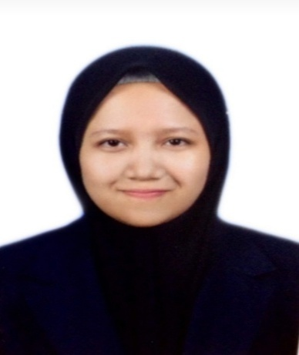

**[norazwaninorazizan@gmail.com](mailto:norazwaninorazizan@gmail.com)**

**(+60) 124822775**

**Kampung Lama Mukim Jitra, 06000 Jitra Kedah Darul Aman.**

**Cashier**

Yawata Sdn. Bhd. **|**  *Jan 2017 – May 2017*(*Full Time)*

*April 2020 – June 2020 (Part Time)*

* Cashiers scan items, ensure that prices are quantities are correct, and collect payments.
* Cashier also assist customers by explaining or recommending items, answering questions, and processing exchanges or refunds.

**University**

* Exco Academic in the Faculty Club.
* Exco Welfare in National Secretariat Club
* Exco Discipline in a new student recruitment session.
* Project Leader for club's general meeting.
* Muet Band 3

**Secondary School**

* Excellent curriculum honors ( state-level choir).
* Participate in a district level comedy drama.
* Participate in the school-level Speech Parliament Contest.
* School-level Parliamentary Debate Participants (Quarterfinals).

**ACHIEVEMENTS**

**Diploma ( Information Management )**

June 2017 – Jan 2020 | University Technology Mara (UiTM)

* Diploma in Information Management.

**Physical University Programme**

Jan 2018 – Jan 2020 | University Technology Mara (UiTM)

* AJK in orphanage Ramadhan program.
* Participants in University-level identity camps.
* Participants describing archival materials.
* Participants in welfare community.
* CGPA : 2.99

**Sijil Pelajaran Malaysia**

2012 - 2016 | SMK Seri Mahawangsa

* Result: 5A 2B 2C

***INFORMATION MANAGEMENT***

**ACADEMIC BACKGROUND**

**CAREER BACKGROUND**

**Madam Nor Famiza Bt Tarsik**

Senior Lecturer

04-4562158

norfamiza@uitm.edu.my

**Mr. Yong**

Supervisor of Yawata

04-9176168

Yawata.supermarket@gmail.com

**REFERENCES**

**PROFESSIONAL SKILL**

Photoshop

Illustrator

Animate

Microsoft Word

Microsoft Excel

**PROFILE SUMMARY**

Seeking a career in a well-known organization where I can leverage my work experience and utilize my strengths, skills and educational background. I believe that my values and skills will benefit the company in reaching its mission and vision.

**NOR AZWANI**